**Soccer HTB**

1. **Scanning**
2. **Enumeration**
3. **Privilege Escalation**

**Nmap Scan**

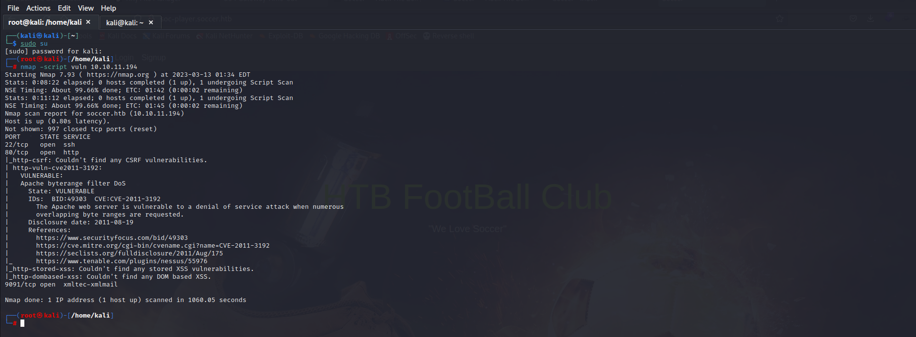

Here in this above picture we have scanned the Soccer.htb and we have found the ports and services running on that ports

**Nano /etc/hosts**

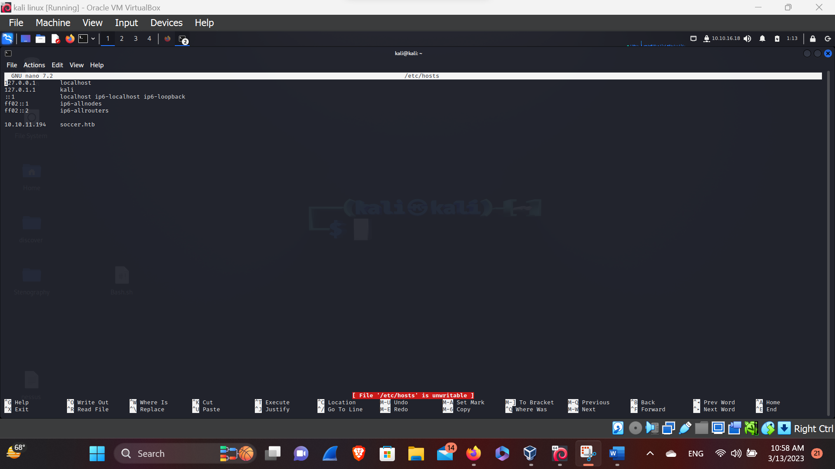

Here, in this above figure we have written the ip and the url name so that we can get access in the page.

**Soccer.HTB**

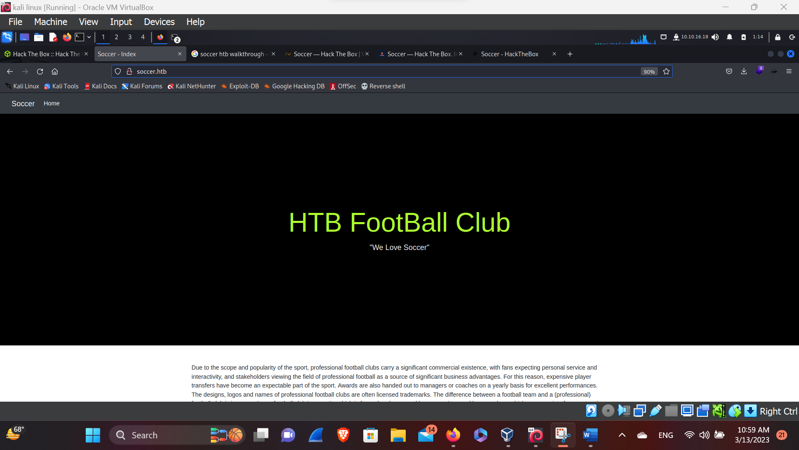

Here in this above picture we have now accessible to the office page of the ip address.

**Dirb & Gobuster**

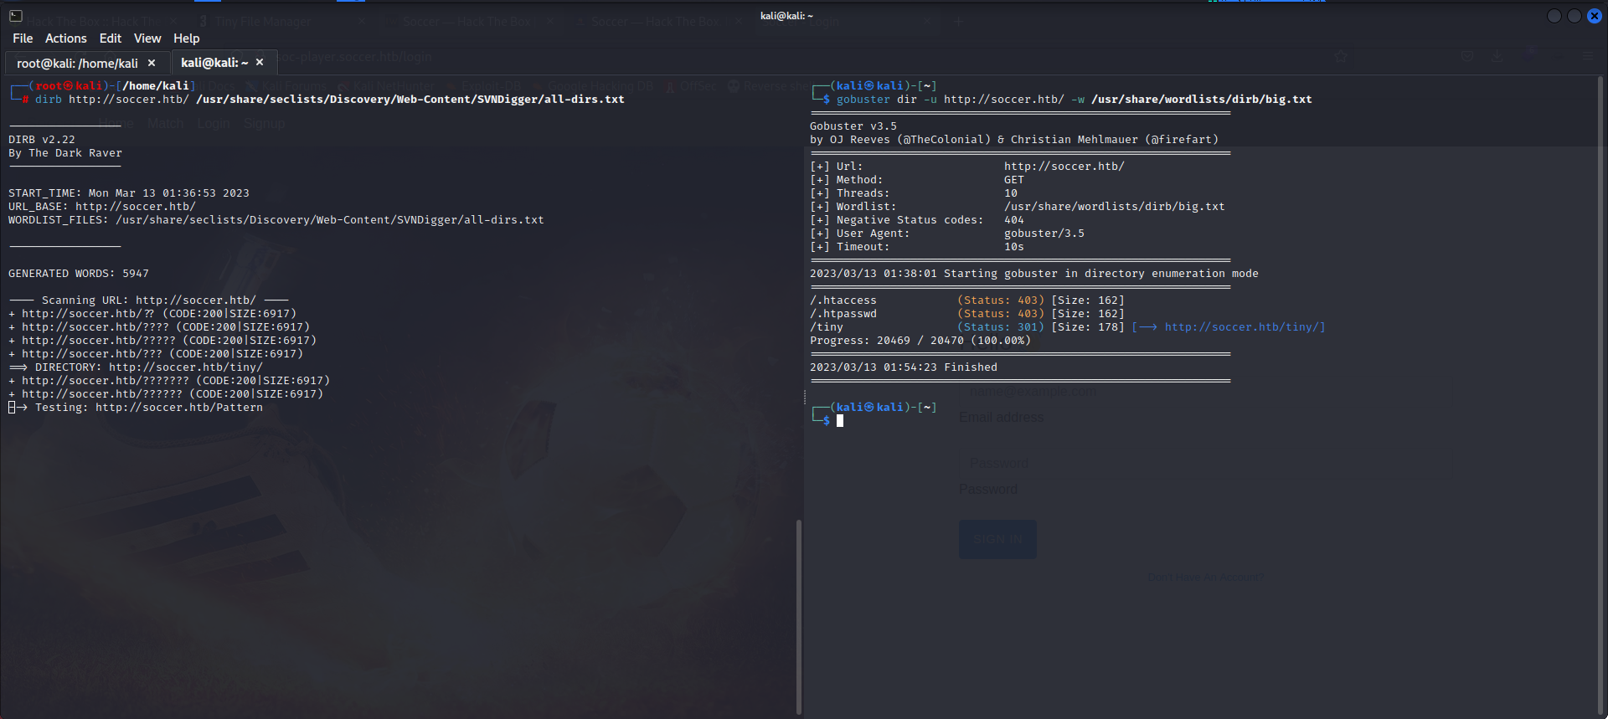

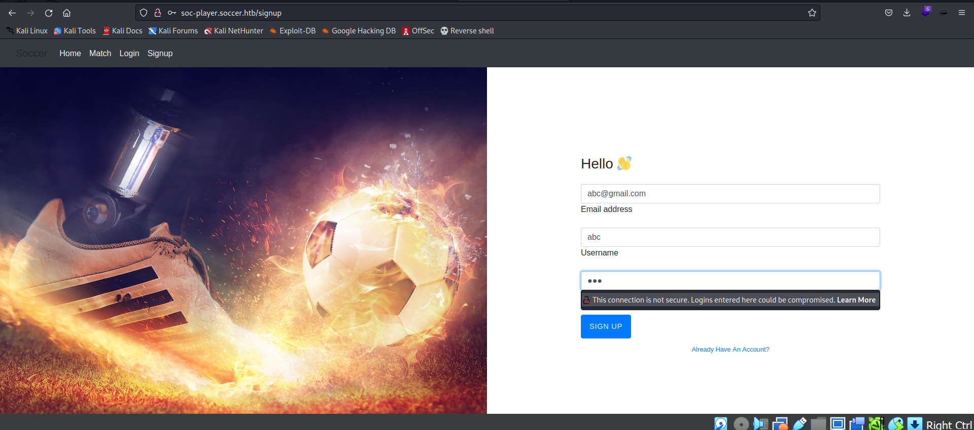

Here, in this above picture we have done the directory search in which the gobuster has been found the hidden directory named /tiny . so here in the down picture we have listed the site name

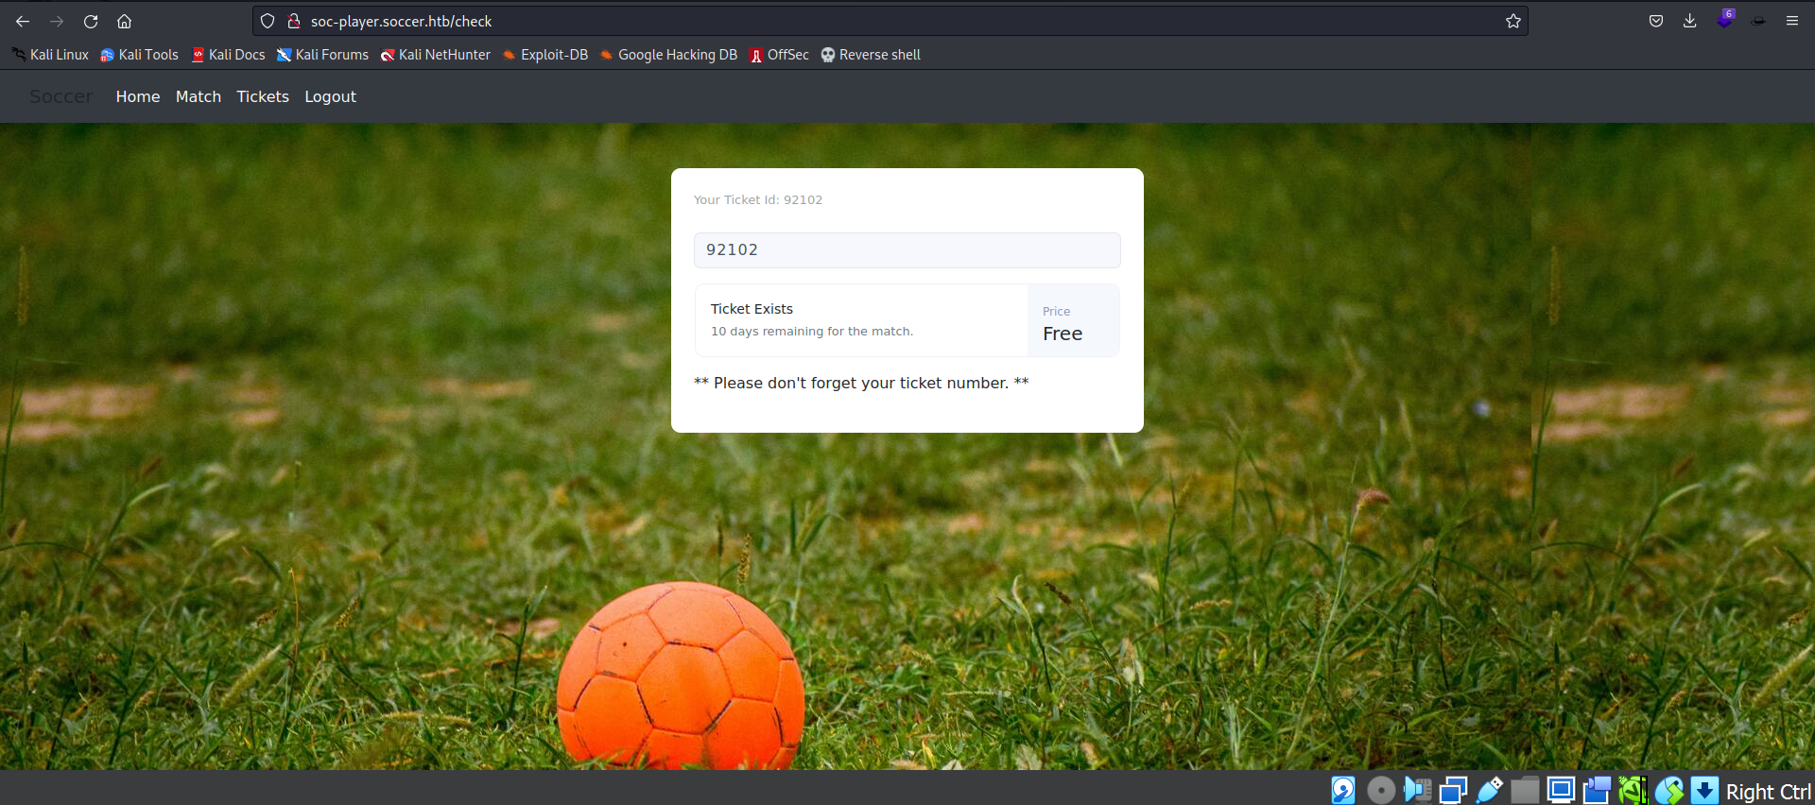

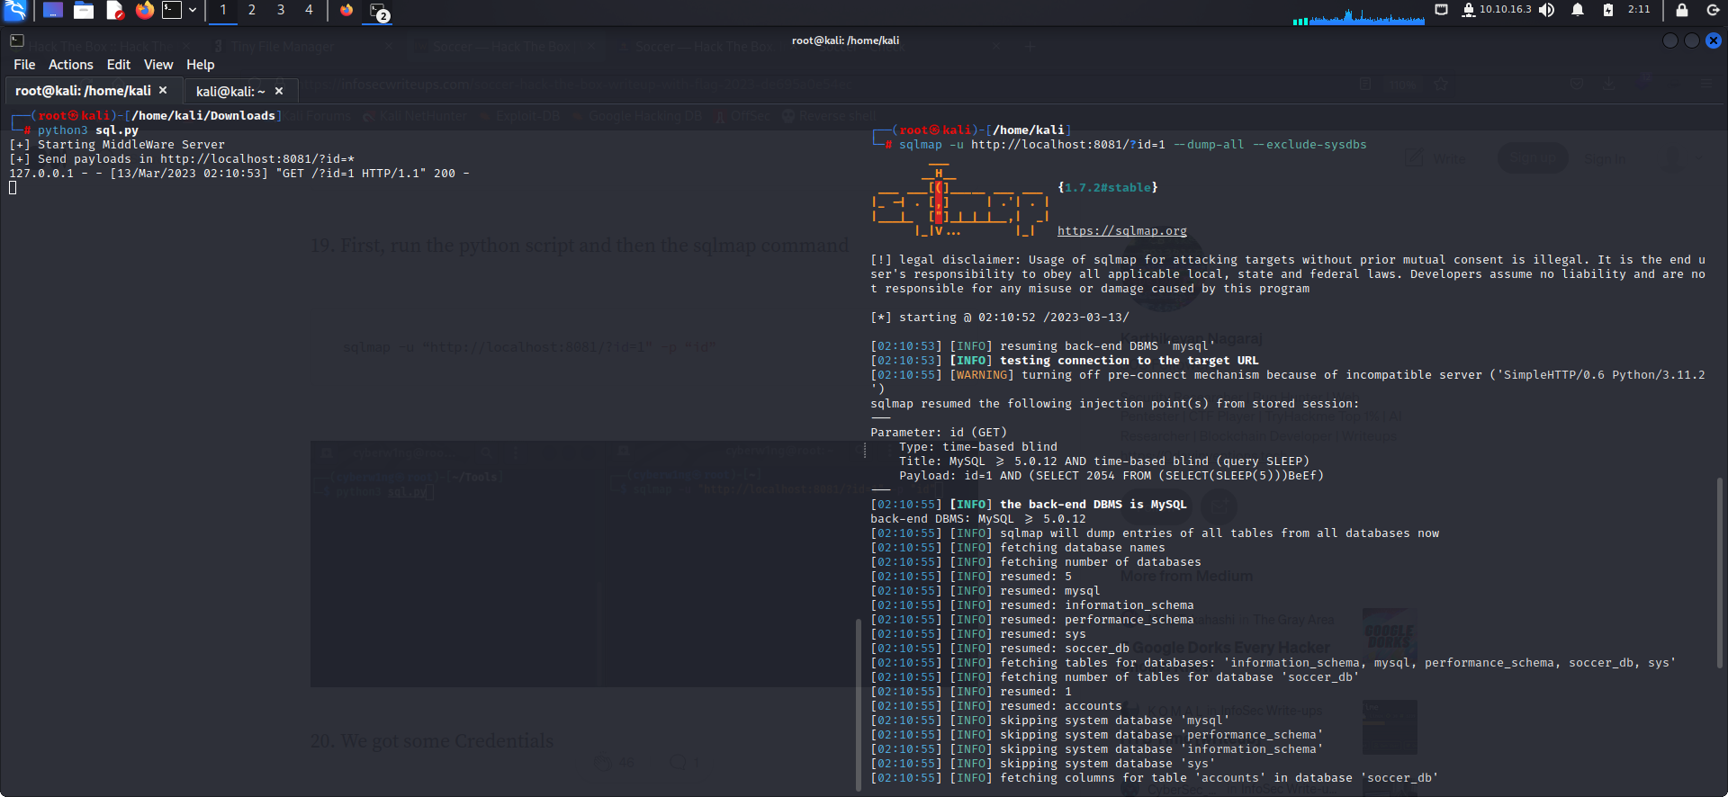

Here in this above figure we have logged in the site, but it requires the ticket. To get in

So I’ve tried to login in the database through the SQLmap for the username and the password.

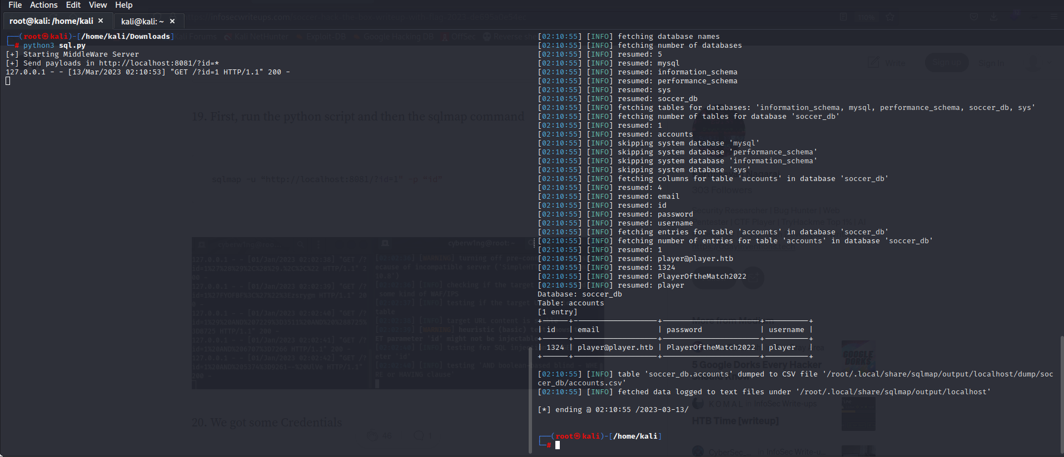

Here, in this above picture we have found the username, Email and the password through which we can login into the ssh for the privilege Escalation.

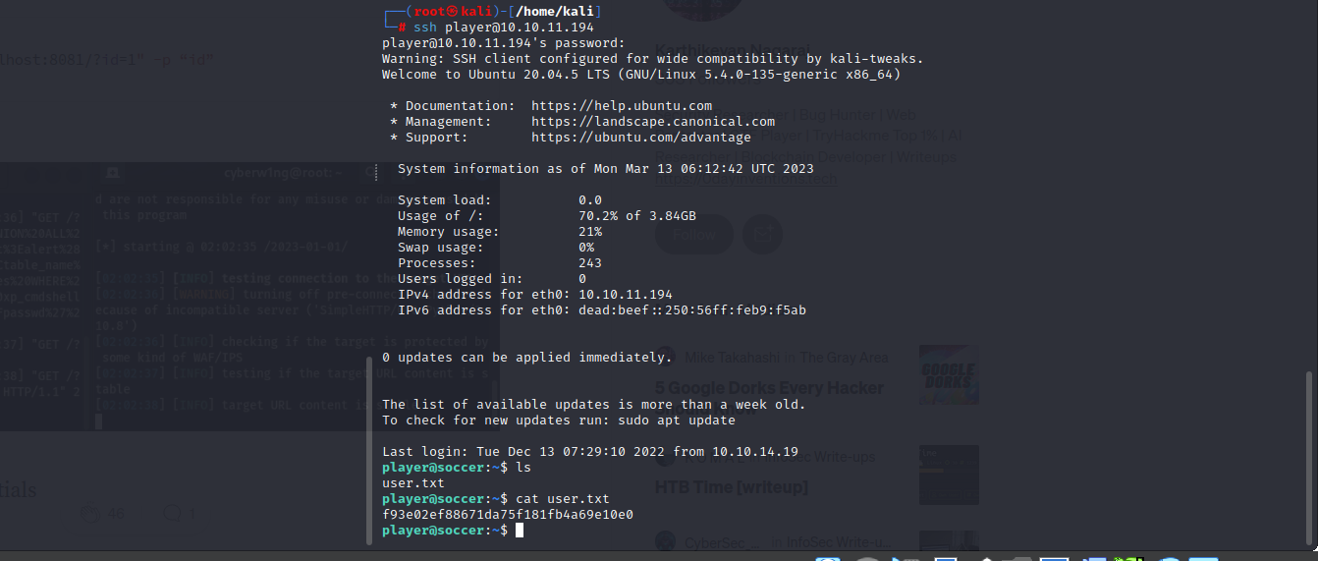

Here, in this above picture we can see that we can login in the ssh Account. And here we can see the user flag.

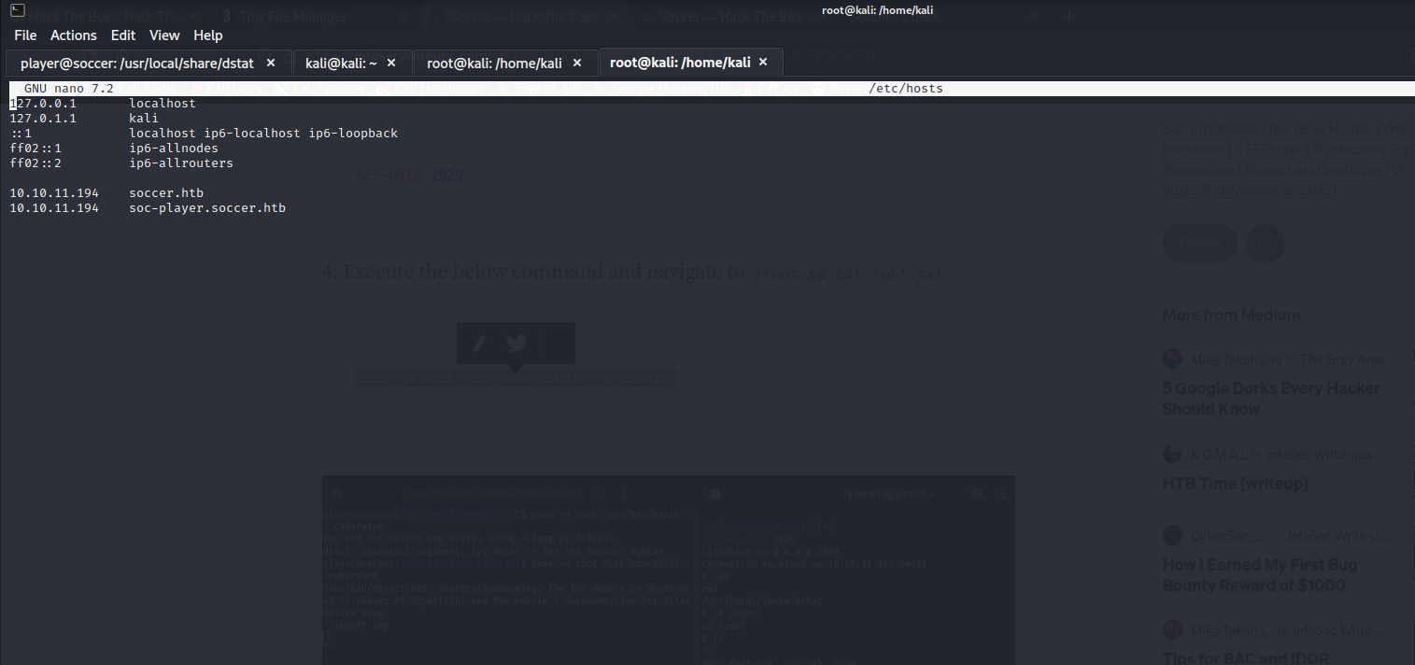**/etc/hosts/**

Here, in this above picture we have put on the ip address and the sites that are available in the